SMART WASTE MANAGEMENT

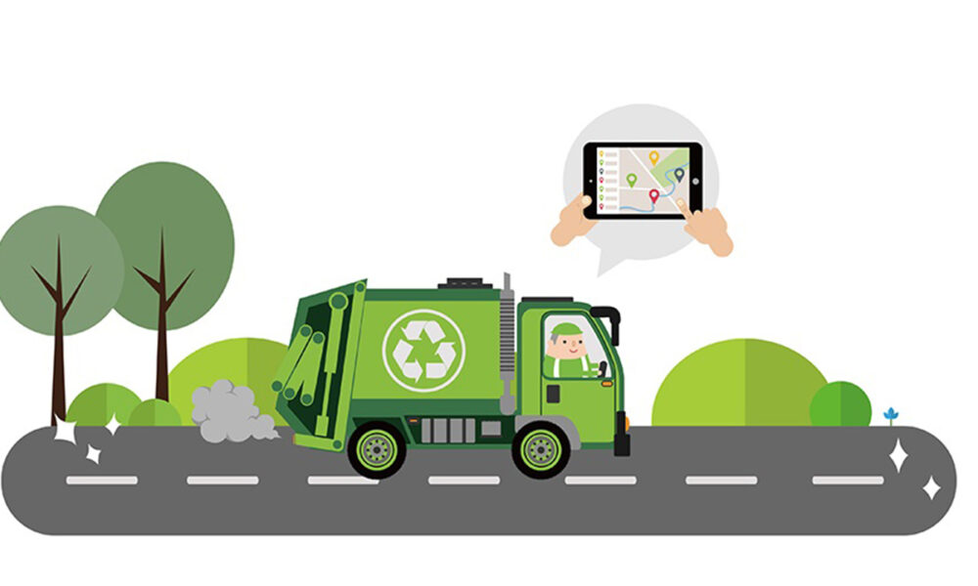

PROJECT PLANNING PHASE

|  |  |
| --- | --- |
| **DATE** | **24.10.2022** |
| TEAM ID | **PNT2022TMID34358** |
| **PROJECT NAME** | **SMART WASTE MANAGEMENT FOR METROPOLITAN CITIES** |
| **MAXIMUM NUMBER** | **4 MARKS** |

**TEAM LEADER**

* MEENAKSHI.R

**TEAM MEMBER:**

* Kavitha.s
* MARY JAVKEY RUHISHA.S
* LIBISHA.K.J

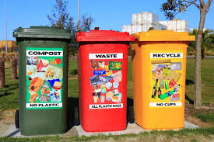

***Think outside the trash..******Recycle!******Don't throw money in the trash – recycle all – it's your decision..!!!***

**SPRIT DELIVERY PLAN**

**Product Backlog, Sprint Schedule, and Estimation (4 Marks)**

Use the below template to create product backlog and sprint schedule

|  |  |  |  |  |  |  |  |  |
| --- | --- | --- | --- | --- | --- | --- | --- | --- |
| **SPRINT** | **FUNCTIONAL**  **REQUIREMENT (Epic)** | **USER STORY** | **USER STORY/TASK** | **STORU POINT** | **PRIORITY** | **TEAM MEMBER** |  | **Team**  **Members** |
| Sprint-1 | Login | USN-1 | As a Administrator, I need to give user id and passcode for ever workers over there in municipality | 10 | High | Meenakshi.R |  | Gogul |
| Sprint-1 | Login | USN-2 | As a Co-Admin, I’ll control the waste level by monitoring them vai real time web portal. Once the filling happens, I’ll notify trash truck with location of bin with bin ID | 10 | High | Meenakshi.R |  | Sathish |
| Sprint-2 | Dashboard | USN-3 | As a Truck Driver, I’ll follow Co-Admin’s  Instruction to reach the filling bin in short roots and save time | 20 | Low | Kavitha.S |  | Shree Vikash |
| Sprint-3 | Dashboard | USN-4 | As a Local Garbage Collector, I’II gather all the waste from the garbage, load it onto a garbage truck, and deliver it to Landfills | 20 | Medium | Mary Jackey Ruhisha.S |  | Sreejith |
| Sprint-4 | Dashboard | USN-5 | As a Municipality officer, I'll make sure everything is proceeding as planned and without any problems | 20 | High | Libisha.K.J |  | Naveen |

**Project Tracker, Velocity & Burndown Chart: (4 Marks)**

|  |  |  |  |  |  |  |
| --- | --- | --- | --- | --- | --- | --- |
| **Sprint** | **Total Story Points** | **Duration** | **Sprint Start Date** | **Sprint End Date (Planned)** | **Story Points**  **Completed (as on**  **Planned End Date)** | **Sprint Release Date**  **(Actual)** |
| Sprint-1 | 20 | 6 Days | 25 Oct 2022 | 29 Oct 2022 | 20 | 29 Oct 2022 |
| Sprint-2 | 20 | 6 Days | 31 Oct 2022 | 05 Nov 2022 | 20 | 05 Nov 2022 |
| Sprint-3 | 20 | 6 Days | 07 Nov 2022 | 12 Nov 2022 | 20 | 12 Nov 2022 |
| Sprint-4 | 20 | 6 Days | 14 Nov 2022 | 19 Nov 2022 | 20 | 19 Nov 2022 |
|  |  |  |  |  |  |  |
|  |  |  |  |  |  |  |
|  |  |  |  |  |  |  |

**Velocity:**

Imagine we have a 10-day sprint duration, and the velocity of the team is 20 (points per sprint). Let’s calculate the team’s average velocity (AV) per iteration unit (story points per day)





 